CSD-325 Module 3.2 Assignment: Brownfield Development and Flowcharting
Name: Nicholas Zankl (https://github.com/nevrik-hub/CSD-325)
Course: CSD-325 Advanced Python Programming
Date: August 30, 2026
Assignment Overview
This assignment focuses on brownfield software development by analyzing and modifying Al Sweigart’s legacy chohan.py application. The objectives required updating existing business logic, customizing prompt interfaces, implementing new payout rules, and creating execution flowcharts to document the application's before and after states.
Summary of Code Modifications
The following primary updates were implemented in the revised script:
- Custom User Prompt: Updated the input prompt parameter from standard > to custom string mss: across both the bet amount entry loop and the CHO/HAN guess selection loop.
- Introductory Rules Update: Expanded the header text block to explicitly inform players of a new 10 mon bonus condition for specific dice totals.
- Bonus Payout Logic: Added conditional evaluation (if rollTotal == 2 or rollTotal == 7:) after rolling dice1 and dice2 to award a 10 mon bonus directly to purse prior to checking the primary win/loss condition.
- House Fee Increase: Modified the winning bet fee calculation from a 10% integer division (pot // 10) to a 12% house fee using floating-point conversion (int(pot * 0.12)).
- Bankruptcy Logic Fix: Updated the program termination check from purse == 0 to purse <= 0 to properly process zero or negative balances.

Execution Flowchart Artifacts
Figure 1: Original chohan.py Baseline Execution Flowchart
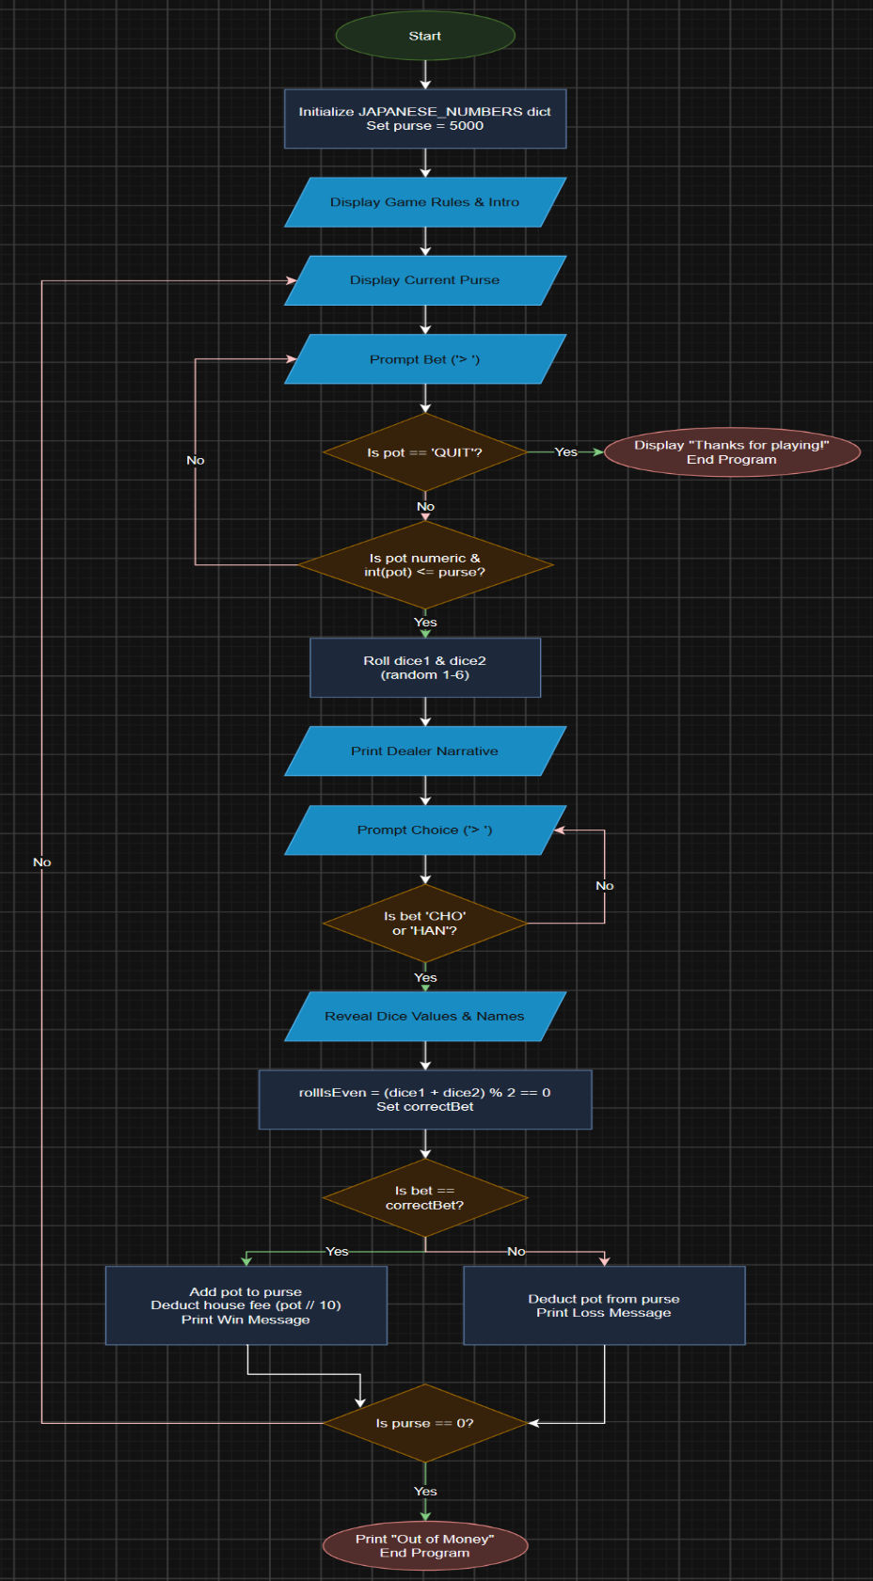
Note: Figure 1 illustrates the legacy workflow, featuring standard input prompts, 10% integer division house fee calculations, and basic win/loss branching without bonus checks.
Figure 2: Revised chohan.py Modified Execution Flowchart
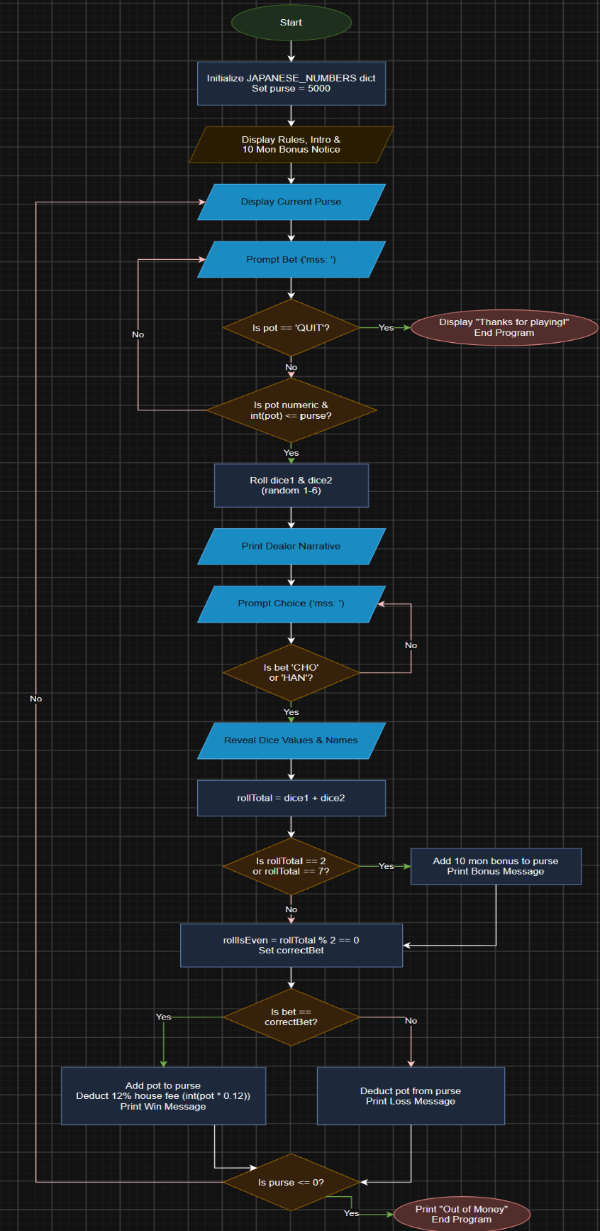
Note: Figure 2 models the updated brownfield architecture, incorporating the custom mss: input prompts, the rollTotal bonus check decision branch, 12% house fee calculations, and purse <= 0 termination validation.
Original vs. Revised Workflow Comparison
Table 1. Summation of Changes
Feature / Workflow | Original chohan.py | Revised chohan.py
Console Prompt | Displays standard prompt (> ). | Displays custom prompt (mss: ).
Bonus Logic | None; standard win/loss payout only. | Evaluates if rollTotal is 2 or 7; awards 10 mon bonus to purse.
House Fee | Deducts 10% fee (pot // 10) on wins. | Deducts 12% fee (int(pot * 0.12)) on wins.
Termination Check | Evaluates purse == 0. | Evaluates purse <= 0.
Testing and Verification Results
- Input Validation: Confirmed mss: displays at prompt locations. Invalid entries (non-numeric values, strings other than 'CHO', 'HAN', or 'QUIT') trigger error messages and re-prompt the user correctly.
Figure 3: Custom Input Prompt (mss:) and Input Validation
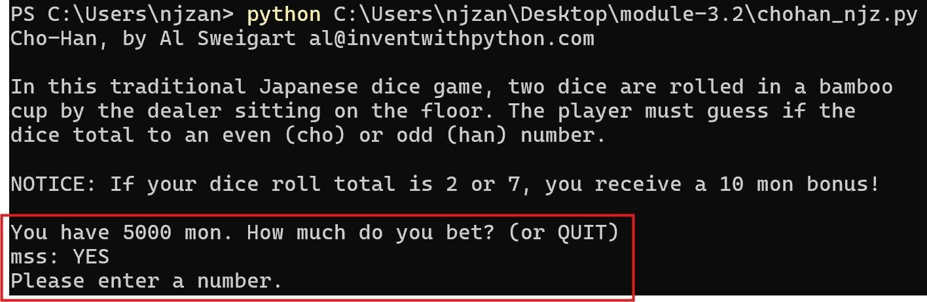

- Bonus Payout Verification: Verified that dice totals equal to 2 or 7 trigger the bonus message and add 10 mon to purse prior to win/loss processing.
Figure 4: 10 Mon Bonus Trigger (Roll Total = 2 or 7)
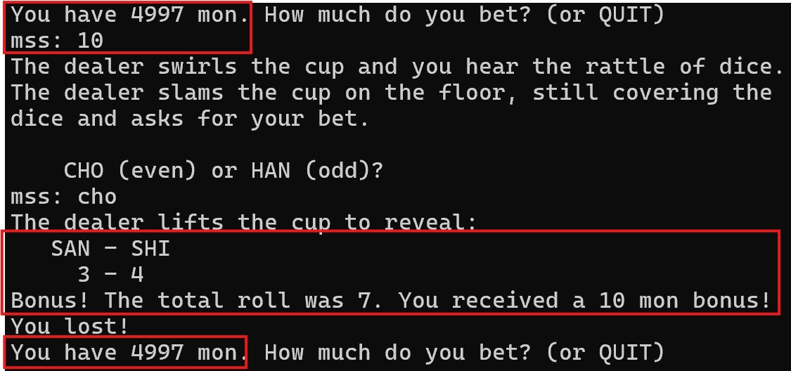
- 12% Fee Calculation: Placed a winning bet of 100 mon; verified that 12 mon (int(100 * 0.12)) was deducted from winnings.
Figure 5: 12% House Fee Payout Calculation
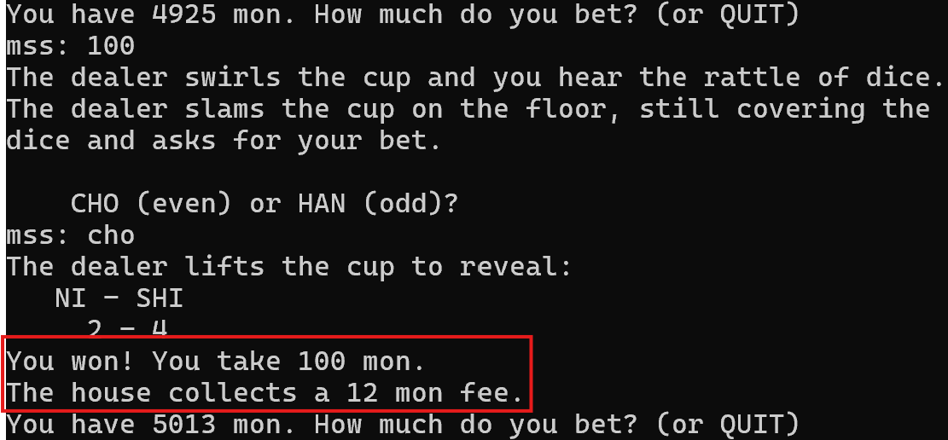

- Game Over Termination: Confirmed that reaching 0 balance displays the "Out of Money" message and cleanly executes sys.exit().
Figure 6: Bankruptcy Game Termination (purse <= 0)
